Lord, I Feel So Weary…
August 22, 2017
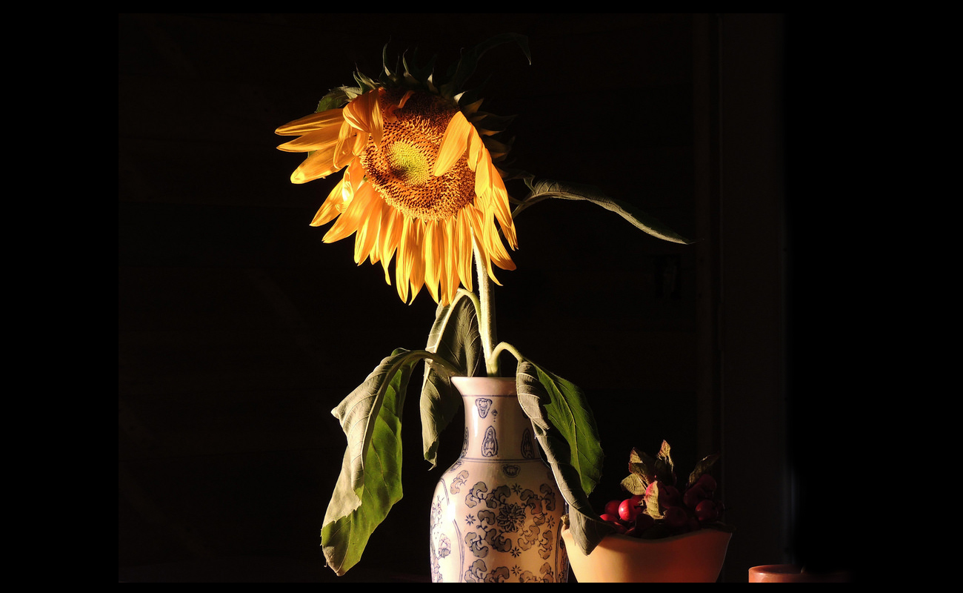
Dear Heartdwellers, let us remember that Jesus rose from the dead and that same resurrection power lives inside of each of us. When we are tempted to give up, call upon Him and He will restore you.

So, between daily thunderstorms…and I do mean gully washers! And carrying a burden for the war, and difficulty with my voice this afternoon, at a critical time…I have to say I’m discouraged. I went to have communion and as soon as I received, He, looking at my flagging frame, called me aside.

Tenderly, He said, "Come here…come aside with Me."

He wrapped His arms around me and held me ever so gently.

"Clare, don’t be discouraged because of your voice. I know this is the hardest thing in the world to do: go slowly and make gradual progress. But this is what I am asking of you, Beloved. You are doing My will. You should not be discouraged or distraught. You are doing precisely what I asked you to do. All your life you’ve been plagued by wanting results instantly—but lasting things, solid things require time and persistent application. So, it didn’t go so well today; it will go better next week. You will see.

"Life has so little meaning without a purpose and you do have a purpose. Two purposes, at the very least. And they are important to Me and you should keep doing them until you get them right."

Forgive me, Lord, I think I am hopeless. I’ve lost confidence in myself and so many things seem to be coming against us…like time being short. (I am always plagued by that thought...) I am old and tired. Please renew me, Lord. Please give me Your strength, Your confidence and Inspiration that I might keep going. Please?

At that point, I was crying.

He continued, "I understand the old and tired thing. That is one thing I didn’t have to battle, but the emotional weight of the people, what was put upon Me, was tremendous and equal to what you call length of years. So many hurting souls. Seeing them from Heaven was one thing; walking among them on Earth… quite another."

What do you mean, Lord?

"I have never lacked for knowledge of anything, Clare. But there is something about being of human estate and relating to My Creation from that vantage point that gave Me something I had not recognized before. The Earth is hard, gravity is hard, aging is hard, walking here among the constraints of a sinful world with negative, invisible forces and demons... is hard.

"I know how you feel and I am ever so sympathetic with you. I truly am.
"But I will enliven you. What raised Me from the dead, Clare, lives in you. Right here. (He put His finger on my heart.) I will burst forth from the boundaries of this flesh if you will allow it."

How do I do that?

"You must believe. Believe that I am who I said I am. Believe that I can do reconstructive miracles, not only of body parts, but hearts and minds. New life, new joy, new strength. I can and will do these things for you, but you MUST believe. Believe in Me, that I am Who I say I AM. Believe in Me, that I will do what I have said I will do."

I answered Him, "Lord, somewhere inside of me I do believe that."

"Good. Call it forth and live it now. You still need more time with Me. You are still stunted in growth because you don’t get it. But I am making a way for that. Be sensitive to My timing and take advantage of the breaks I make in your schedule.

"You are also carrying a burden for your nation. This is a very heavy cross. But have I not promised that I would not give you more than you could handle?"

Jesus, I really feel like I am at the rock bottom.

"Then there is nowhere else to go but up…right?"

He continued, "Go lay down now and take your rest."

So, that's exactly what I did. I went and took a nap, my midnight nap, to get ready for the next 6 hours. And I had my husband pray for me at the same time. He laid hands on me. And I feel 100% better. I feel much, much better.

But I wanted to share this with you, even though it's not a long message. It certainly is encouraging. He is there for you. All you need to do is reach out to Him, and believe in Who He is and what He can do.

I love you all, Heartdwellers. Thank you for taking such good care of us. Thank you for praying for us. We so appreciate it. The Lord bless you.

And I want to, at this point, give a special thanks to those of you who have been taking care of us every month. I can't tell you how much we appreciate it. It makes it possible for us to plan, and dream and work even harder for the website and for the Channel. And books that we're putting together.

And by the way, speaking of books. All you have to do is write to me and I'll send them to you for free. So, there's no constraints on your finances. If you don't have the money to order something from Amazon, please write to me. It's in the information box underneath this video. And I'll be happy to send you what I have.

The Lord bless you all.

